KIT519 Workshop2 Gorup4

- Remember&Understand:

HCI primarily concerns the interaction between the user and the system, where effective Information Design (ID) presents information and organises the layout. This helps users have a positive User Experience (UX). To achieve this, it's essential first to understand the system's requirements and goals, including what information needs to be emphasized or highlighted. Users can be intuitively attracted to the system through ID, such as interactive or visual design. This includes the selection of website fonts, icon design and size, and other visual elements.

The overall user experience should also ensure the system's operation is simple. The website's navigation layout should be easy to understand, enabling users to grasp the site's functionality quickly. Regarding HCI, attention must be paid to the response time and fluidity of interactive experiences. Conversely, UX focuses on the user's emotional reactions, satisfaction, and overall perception of the system throughout the entire usage process.

- Apply&Analyse:
After consulting with other groups, we improved the course page's functionality by adding comments and user star ratings. This enhancement increased the credibility of the course. Additionally, we appropriately added some comments.
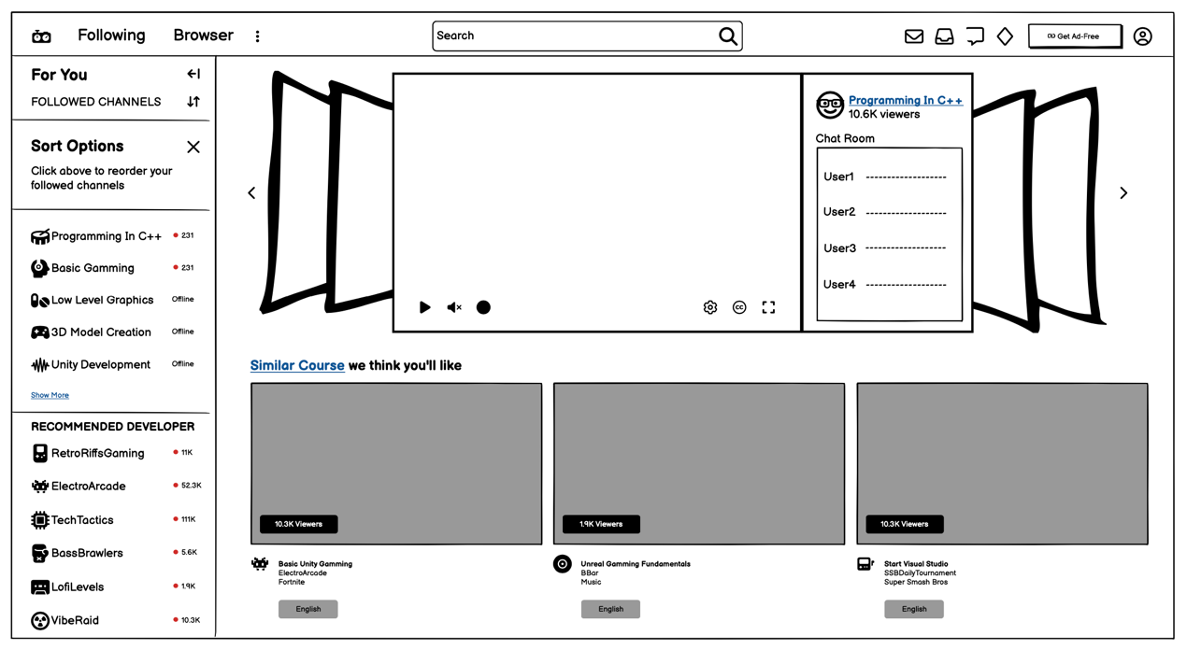
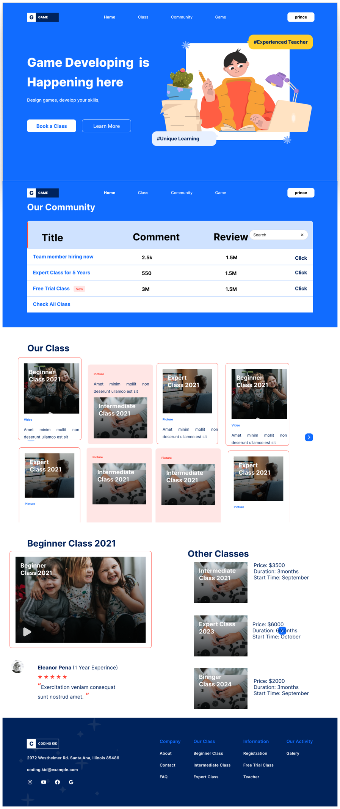
- Evaluate&Create:
